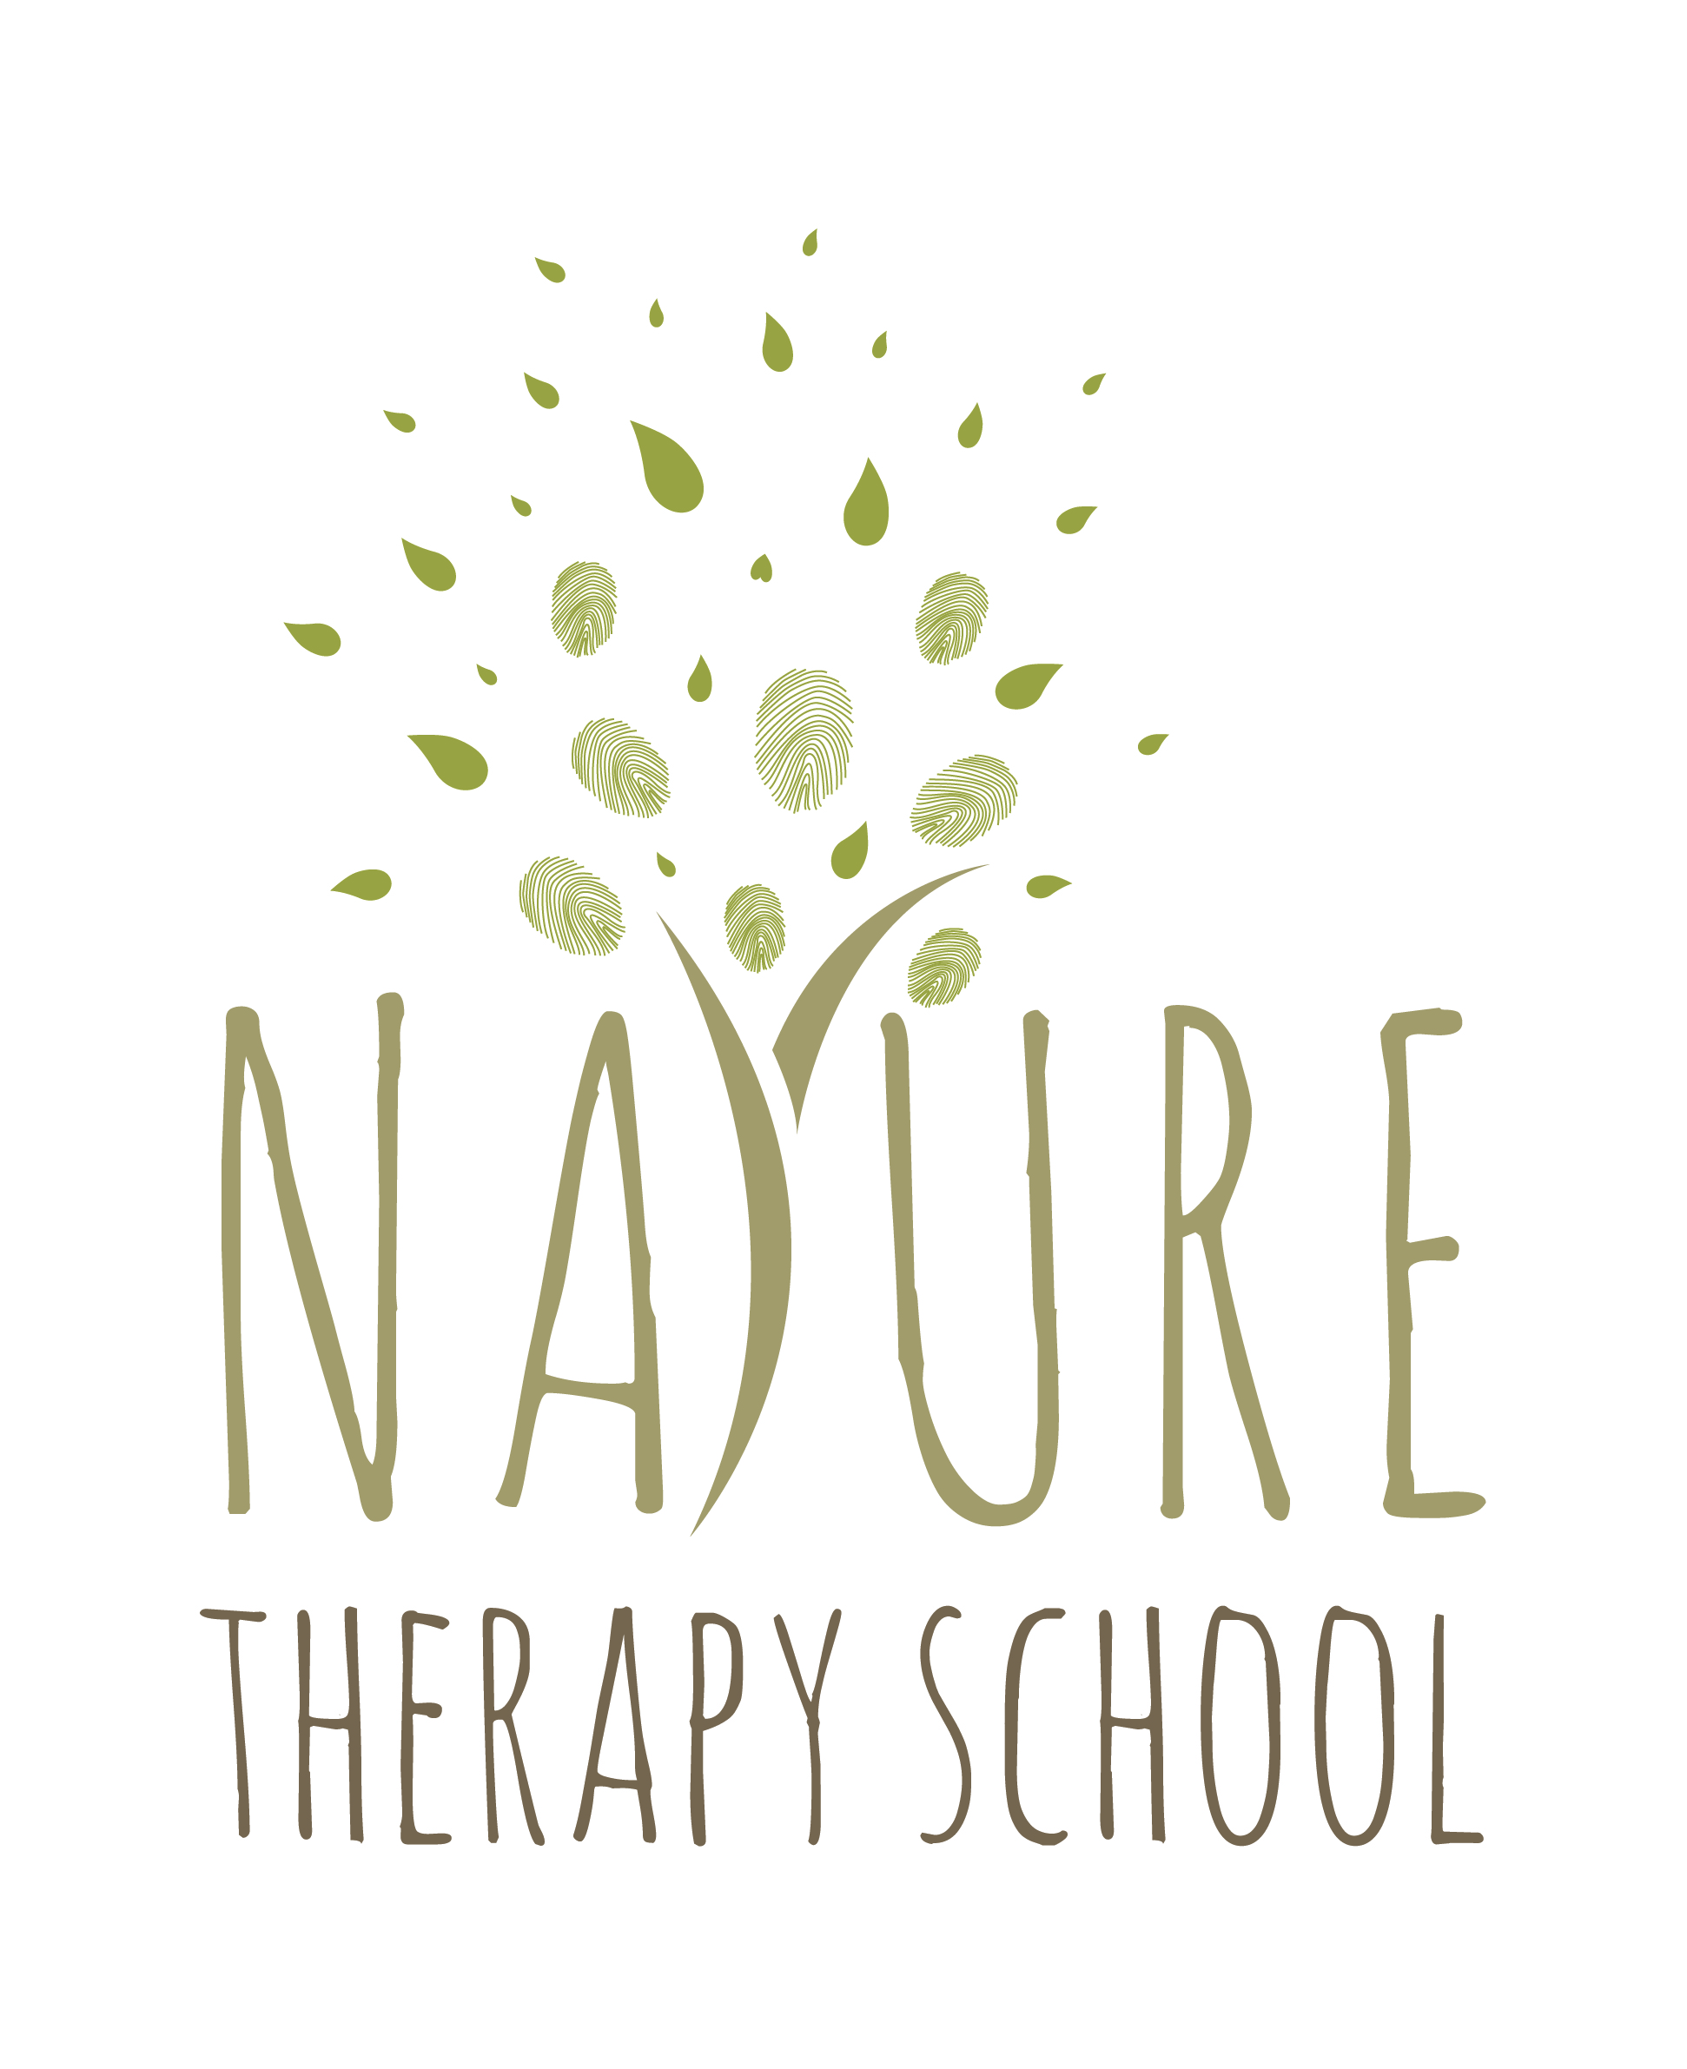
Application Form
Diploma in Nature Allied Psychotherapy

Name:
Address:

Postcode: Email:
Telephone: Mobile:

Previous training in psychotherapy or counselling (Institution, Dates, Qualification):

Have you had experience of personal therapy?

□ no □ yes
please give dates (from and to):

Reasons for applying for the course (your personal statement is an important part of the shortlisting process, 500 words max):

Do you have any prior experience in working with clients in natural settings or facilitating others in nature?
□ Yes □ No
If yes, please describe:

How did you hear about us:

□ Nature Therapy School website
□ Advert in: □ BACP/Therapy Today □ Counselling Directory/Happiful
□ UKCP/New Psychotherapist
□ BAATN
□ Training Institute, please specify:
□ Google, please specify key words searched for:
□ Word of mouth
□ Other:

signed: date:

Return with a copy of your CV to: hello@naturetherapyschool.com

Shortlisted applicants will be invited for an interview either face to face (London area) or by skype.
Equal opportunities monitoring form

This form will be treated in the strictest confidence.

gender

male□ female□ ________□

age

20-29 □ 30-39 □ 40-49 □ 50-59 □ 60-69□ 70+□

ethnicity

□ White British □ Asian British; Indian
□ White European □ Asian British; Pakistani
□ White other: □ Asian British; Chinese
□ Black British, African □ Asian other:
□ Black British, Caribbean □ other – please specify:
□ Black other:
□ Mixed race – please specify :

do you have a disability?

□ no □ yes – please specify:

religion or faith

my religion/faith is:

□ no religion
□ rather not say

